**DATABASE SYSTEMS AND WEB LAB**



**REPORT**

**PROJECT TITLE:**

**SOCIAL CAMPAIGN WEBSITE**

**(GANGA CALLING)**

**Made by:**

* ANSHUMAN TYAGI (9920103063)

**ABSTRACT**

Social campaign system is sustained effort to educate individuals and boost public awareness towards the issues of national interest. It helps us gather support towards the cause. Target people who share your organization's beliefs and values. These campaigns can address groups of people in a region affected by a particular climate threat, groups of stakeholders, the general public, etc. The ultimate aim of such campaigns is **to achieve long-term lasting behavioural changes**. Awareness raising addresses the knowledge of individuals and organisations.

**INTRODUCTION**

We have proposed use of applications to teach and to create social awareness for sensitive topics. We have designed a website to login and signup towards the cause and show their support to improve the degrading quality of water of the holy river Ganges. We have used PHP to store their data.

Our website’s structure has been formed using HTML, in a way such that the users can easily login or signup to support the cause and contribute their selves to the cause. All the pages were designed through CSS.

**ENTITY RELATIONSHIP DIAGRAM**

Users

**APPLICATION**

Login Page:

User will be allowed to login through his email id and password if he is a existing user and if not he will be redirected to the registration page.

Registration Page:

User will be asked for a username, email id, password and password confirmation here and then he will be asked to login at the login page through which he will proceed to the welcome page.

Welcome Page:

The user is congratulated on supporting the cause.

**SOFTWARE REQUIREMENT**

1. Xampp
2. VSCode
3. Brave(or preferred web browser)

**HARDWARE REQUIREMENT**

1. Laptop

**OUTPUT**

**Back-end:**

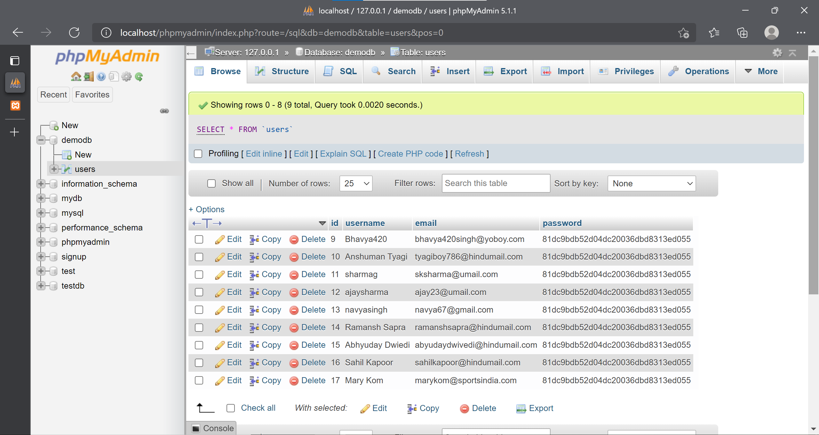

**Front-end:**

*Login Page*:

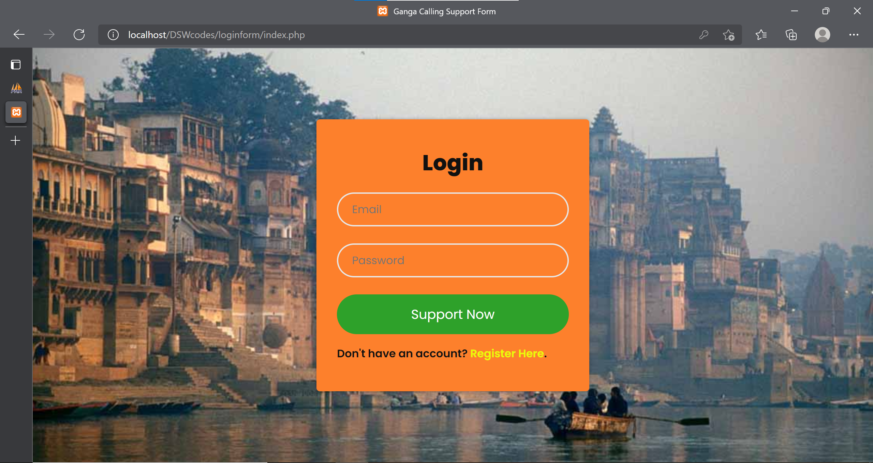

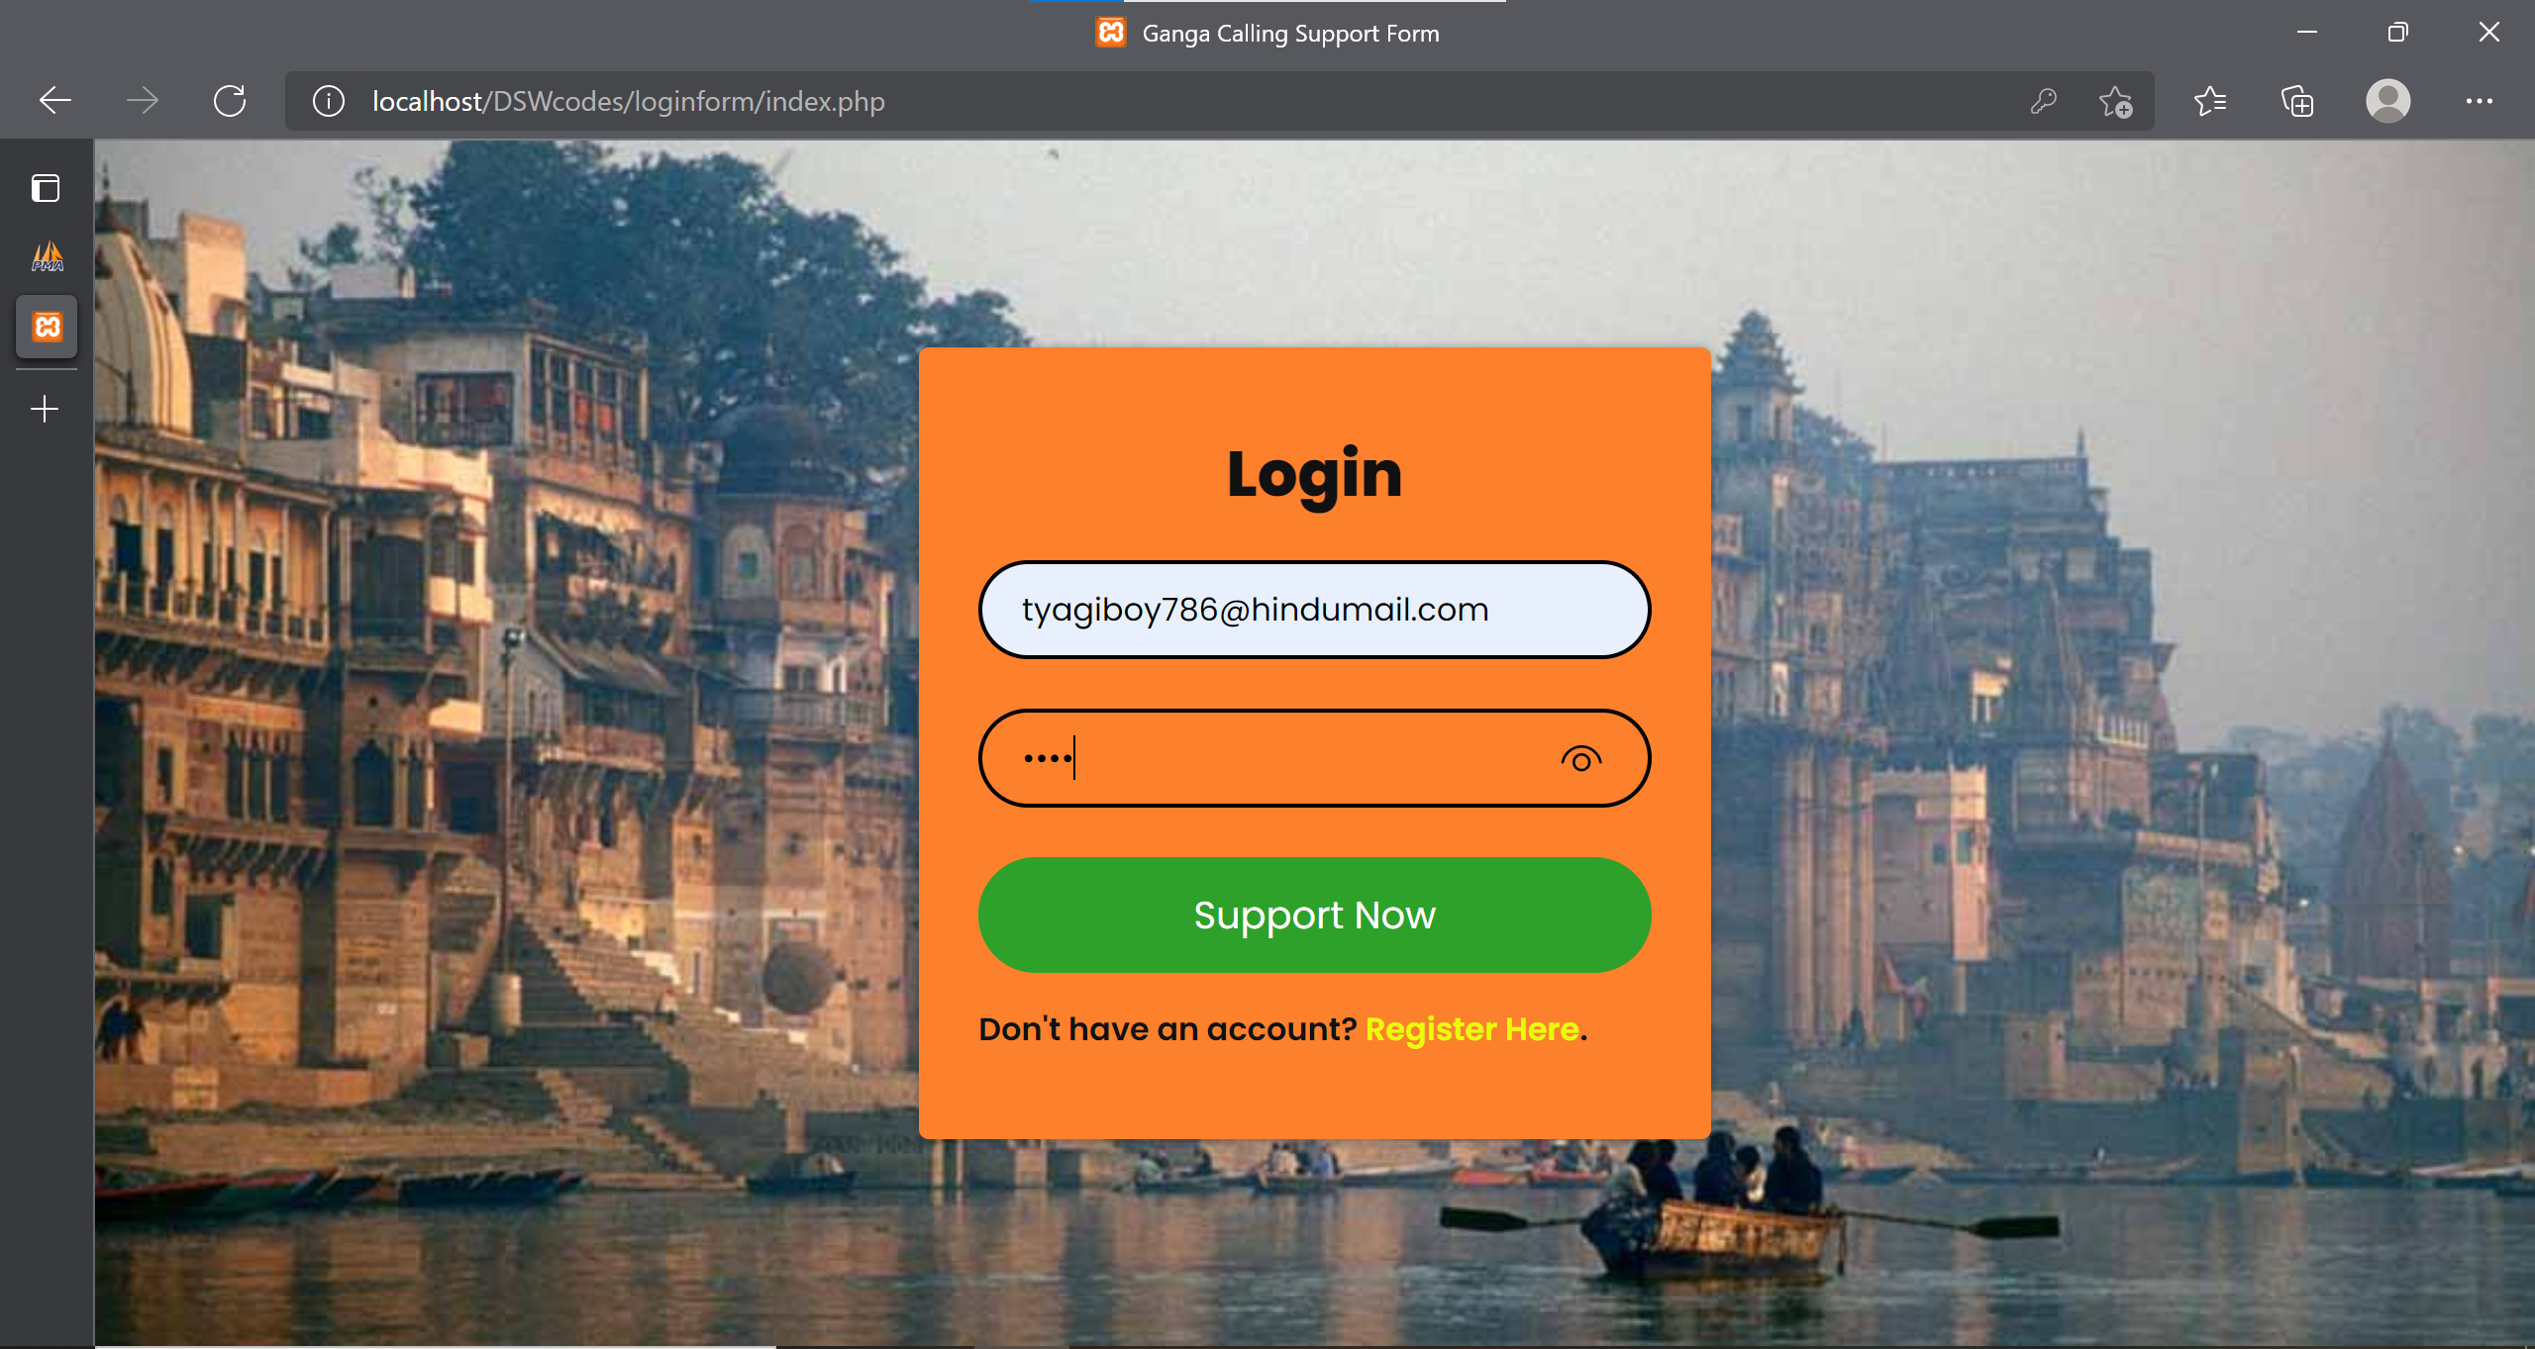

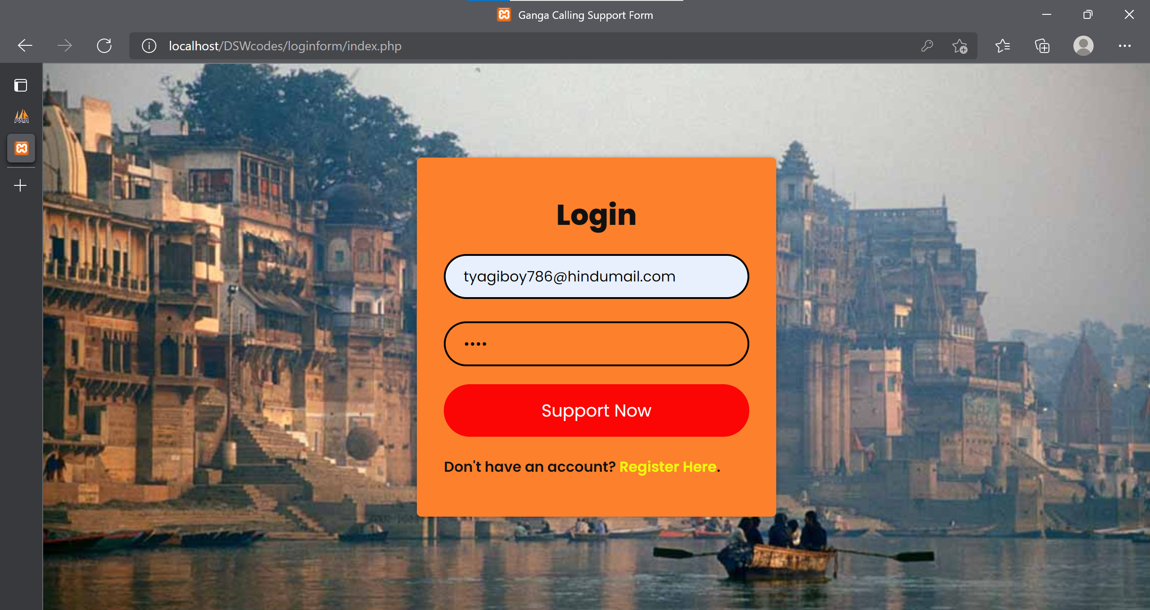

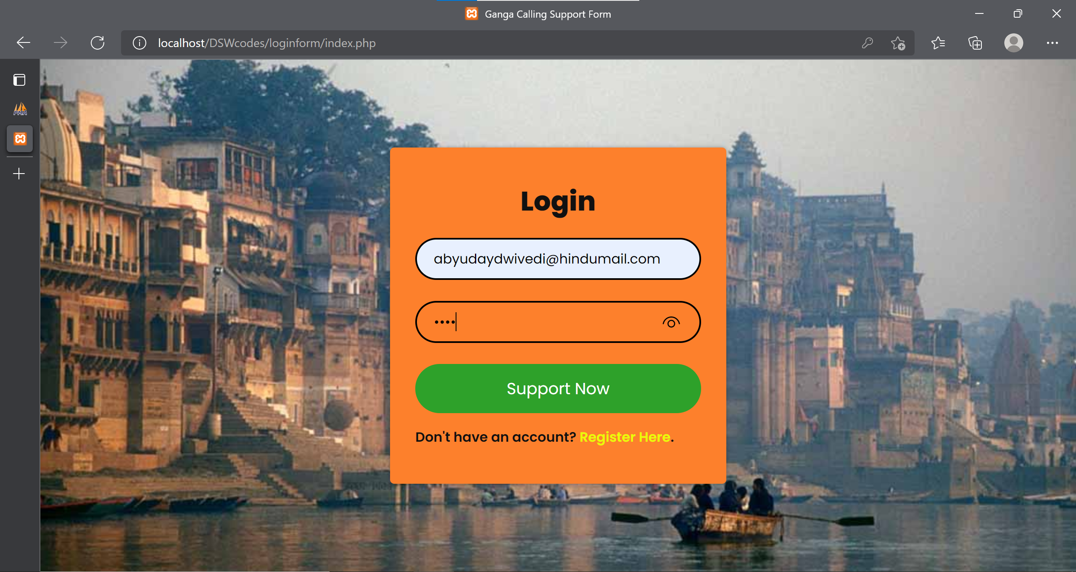

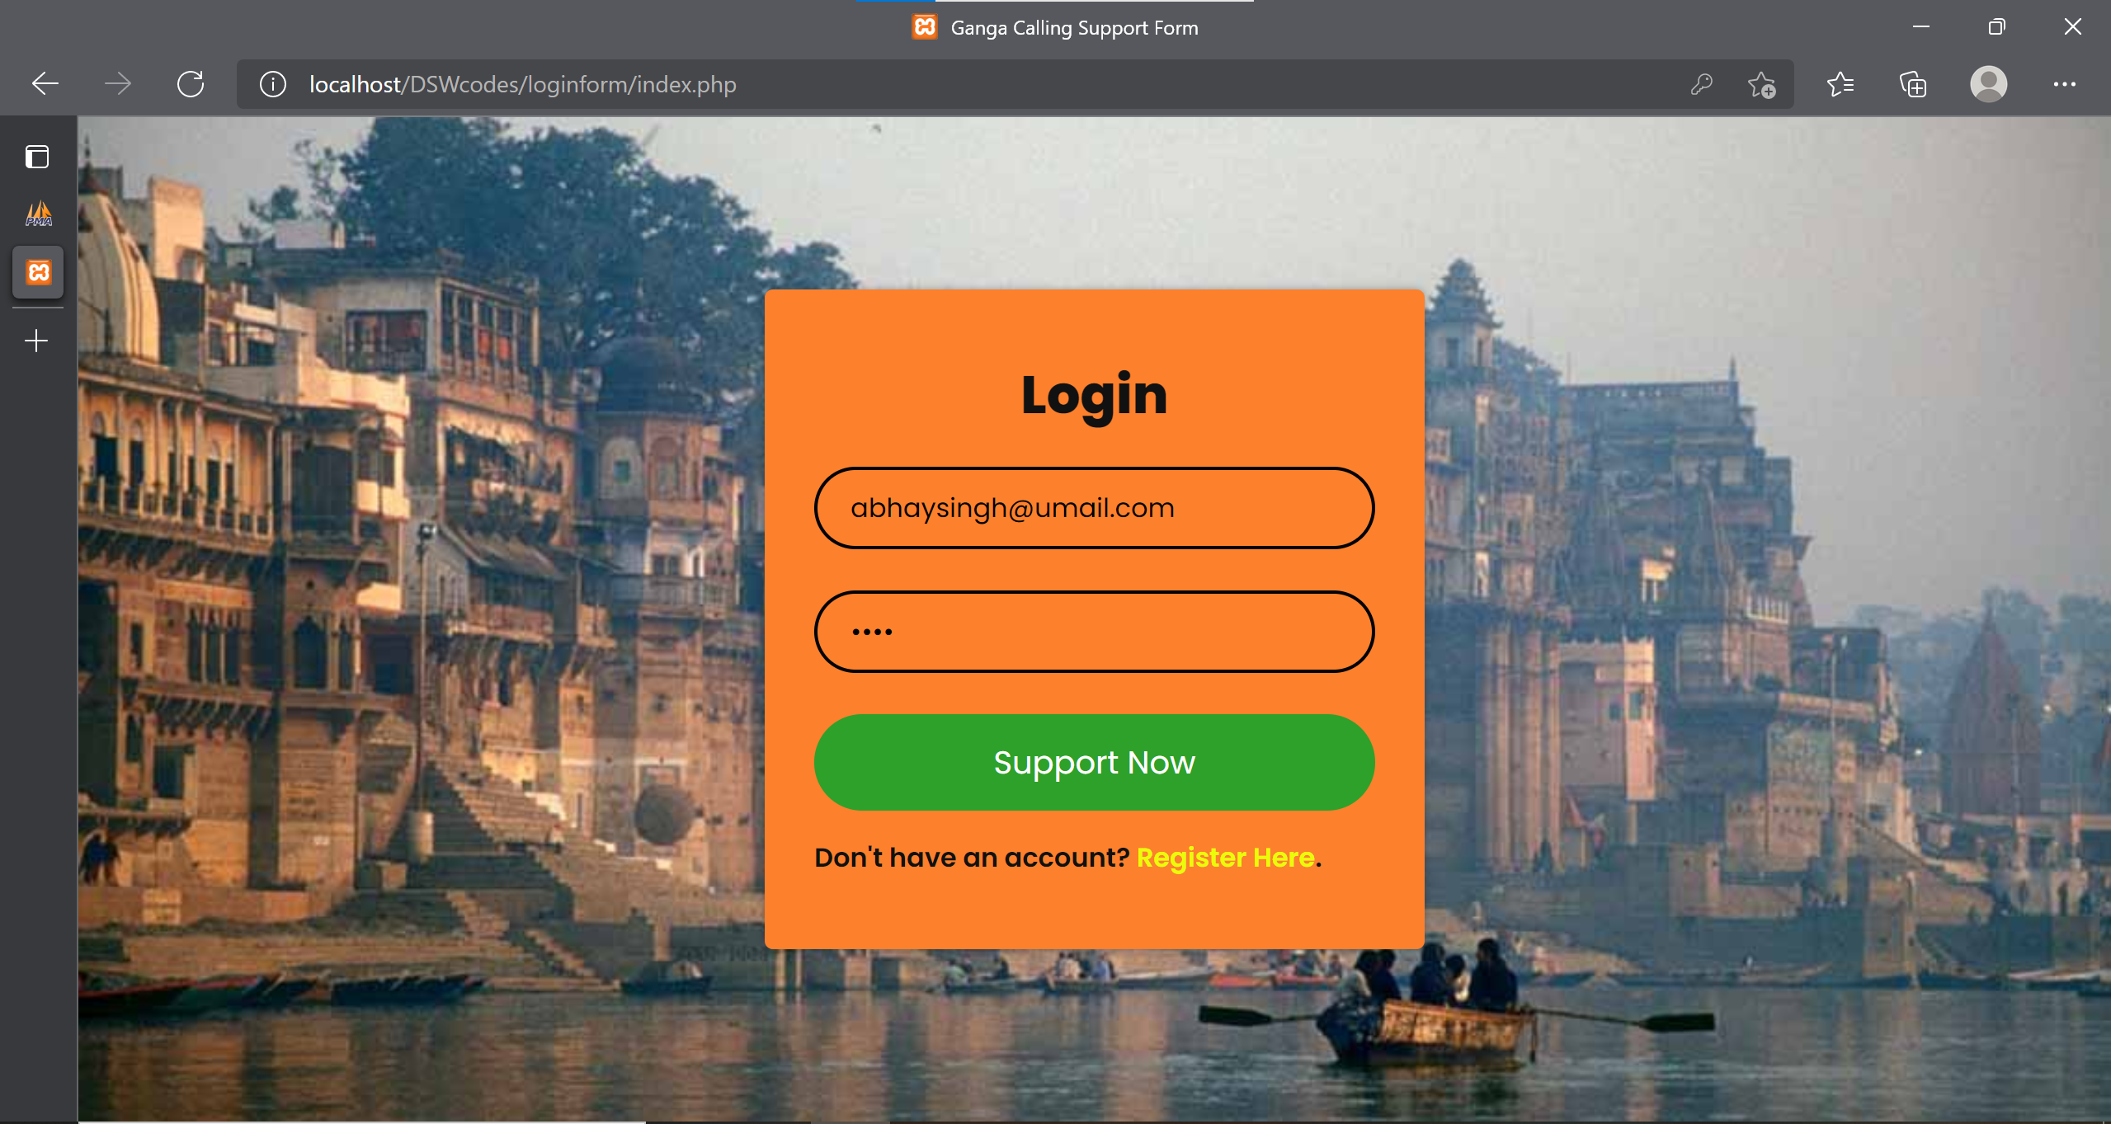

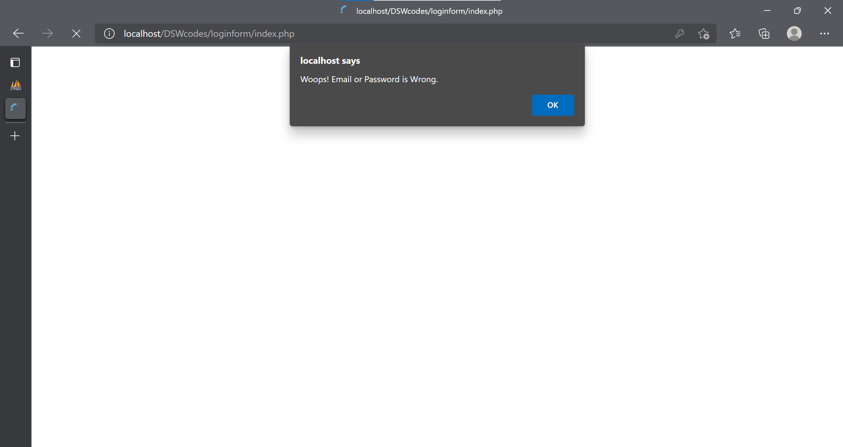

*Registration Page*:

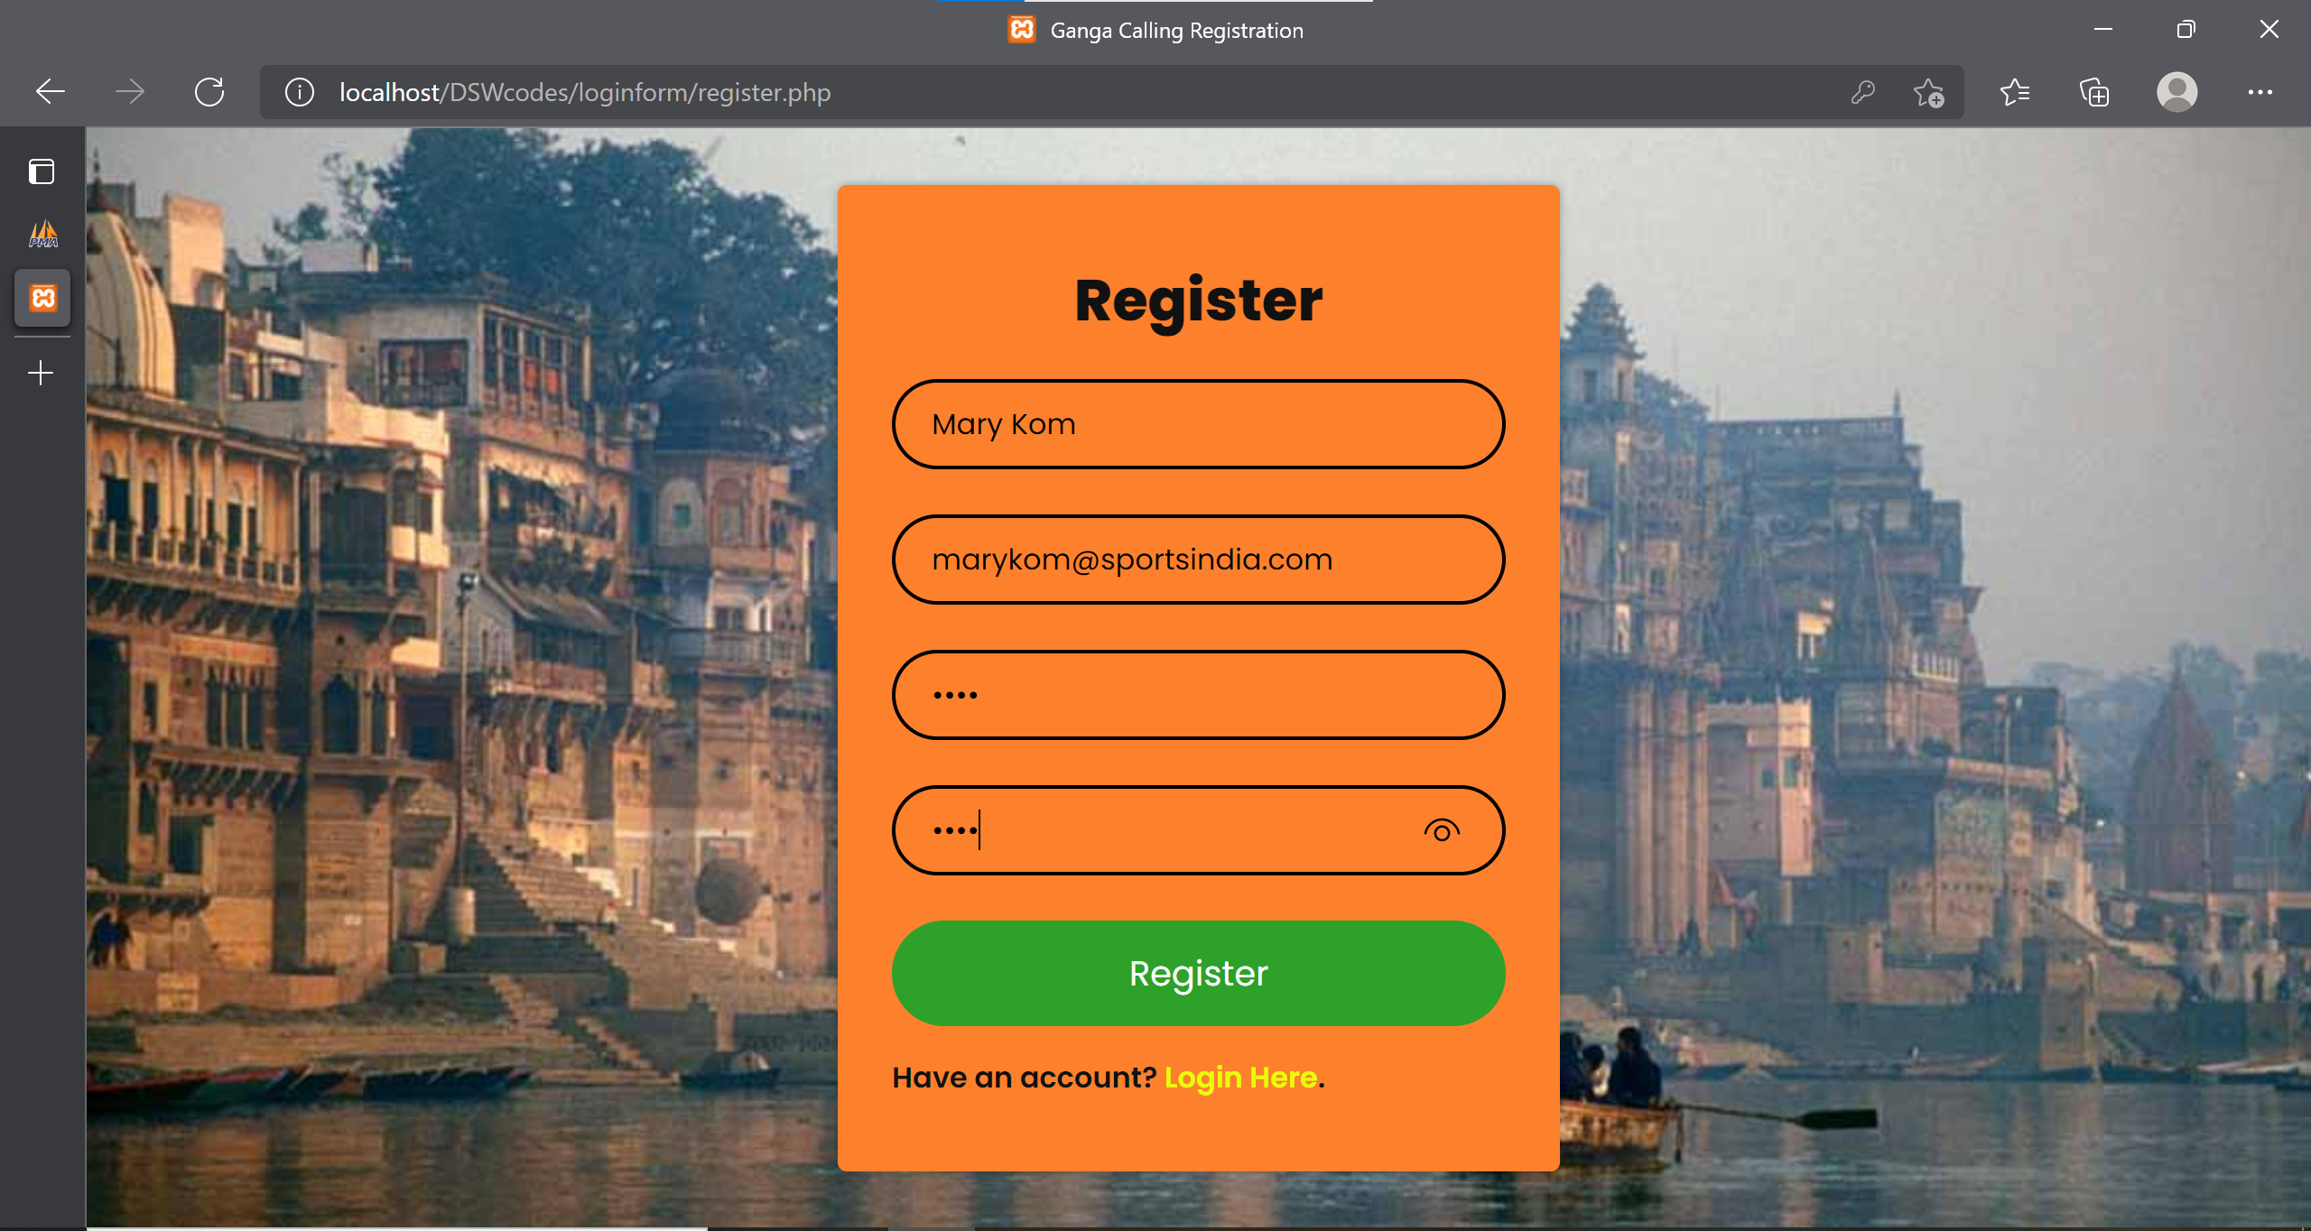

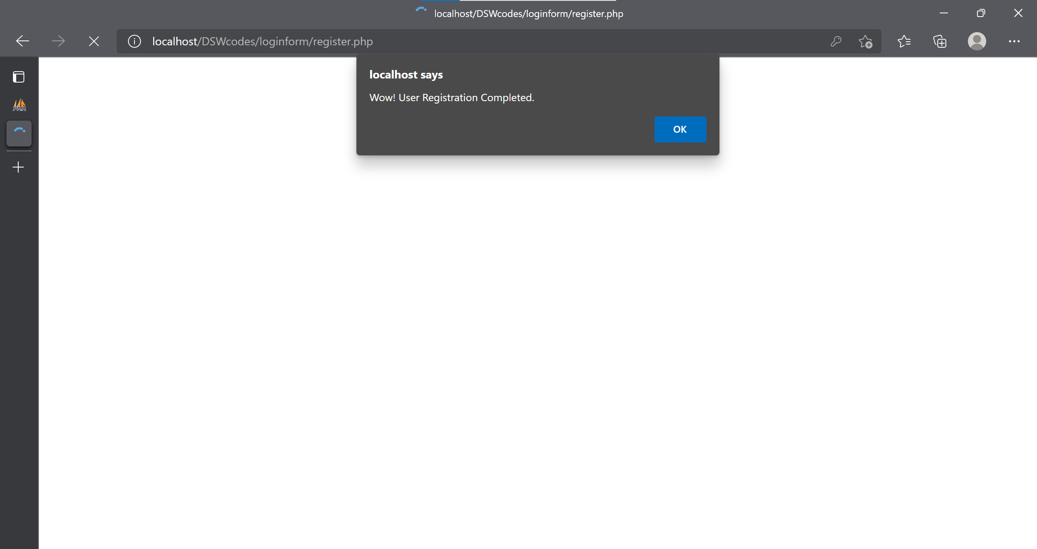

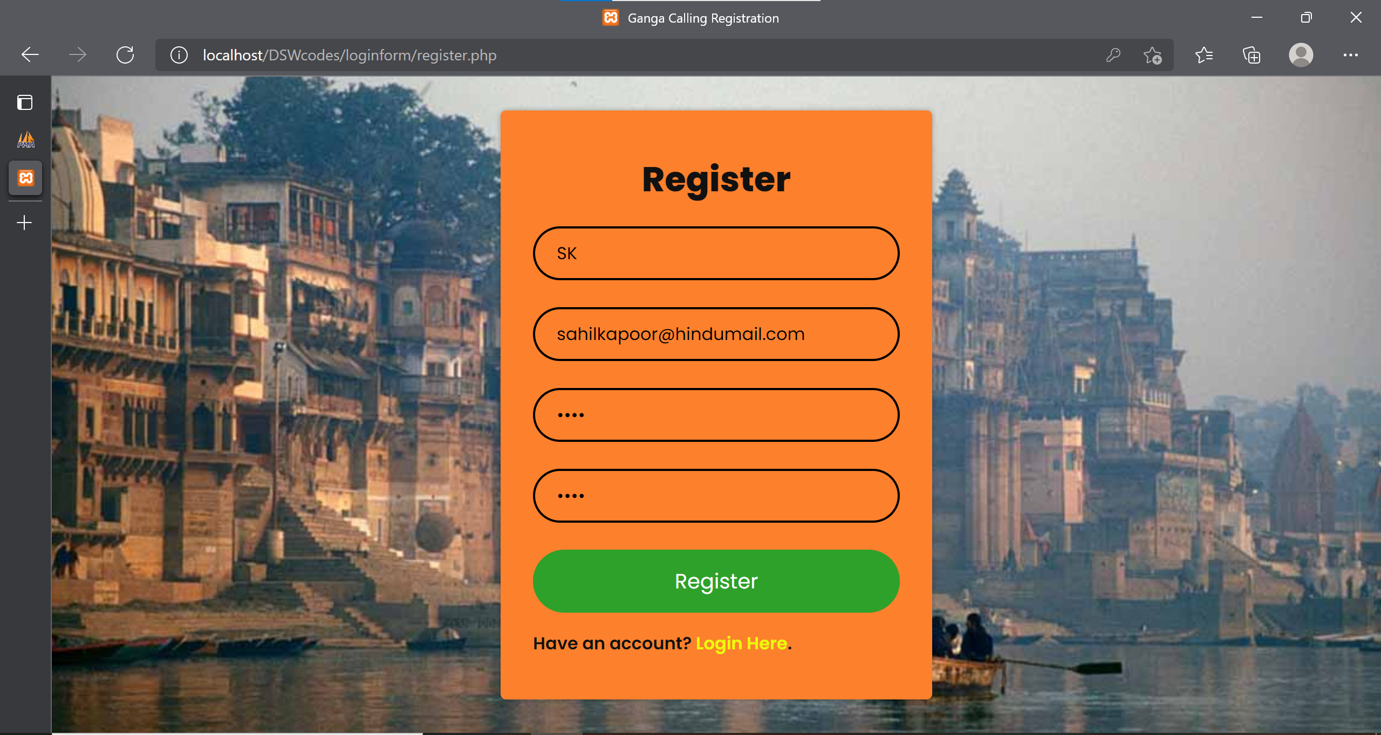

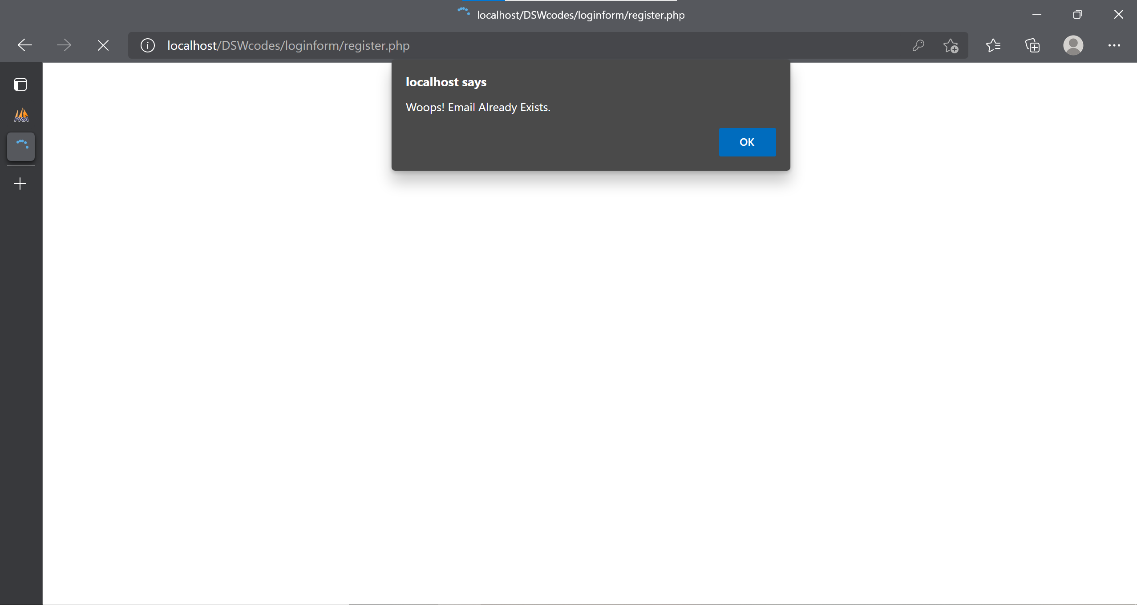

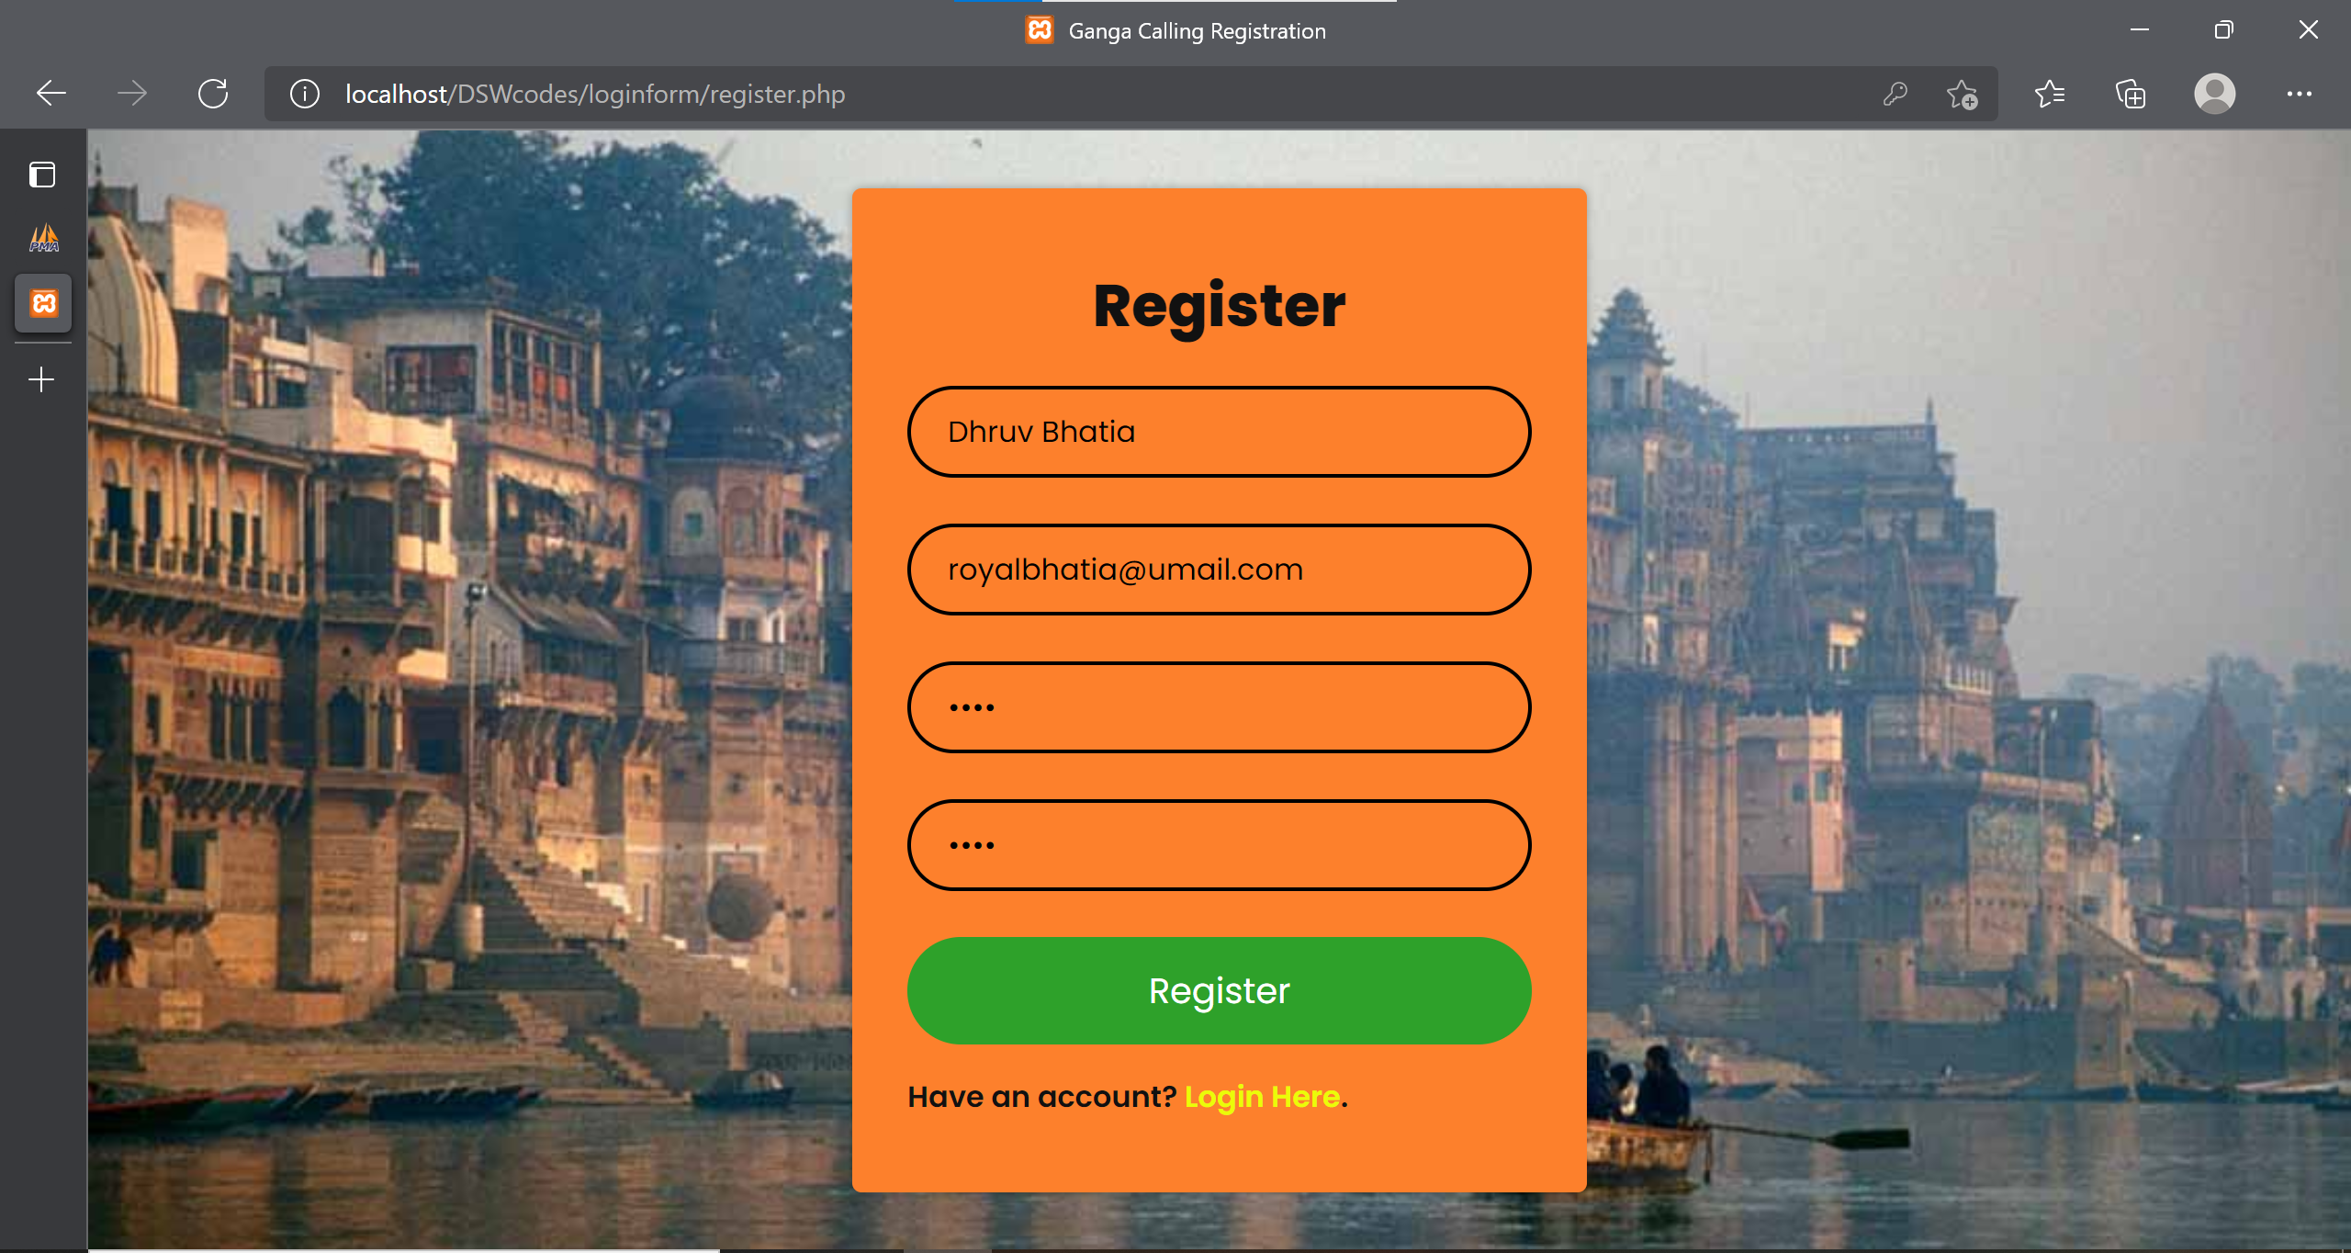

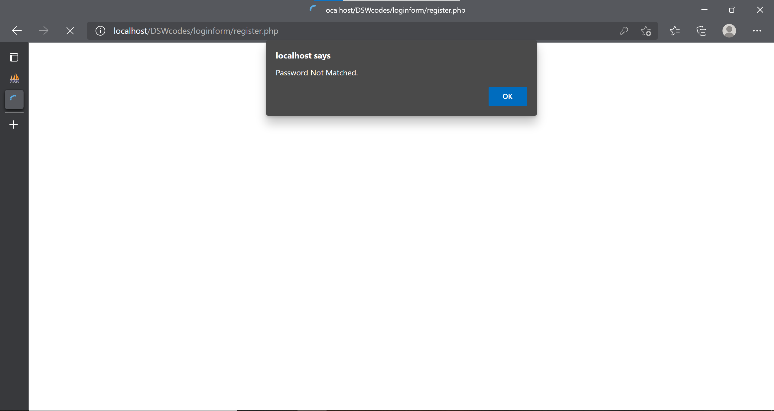

*Welcome Page*:

